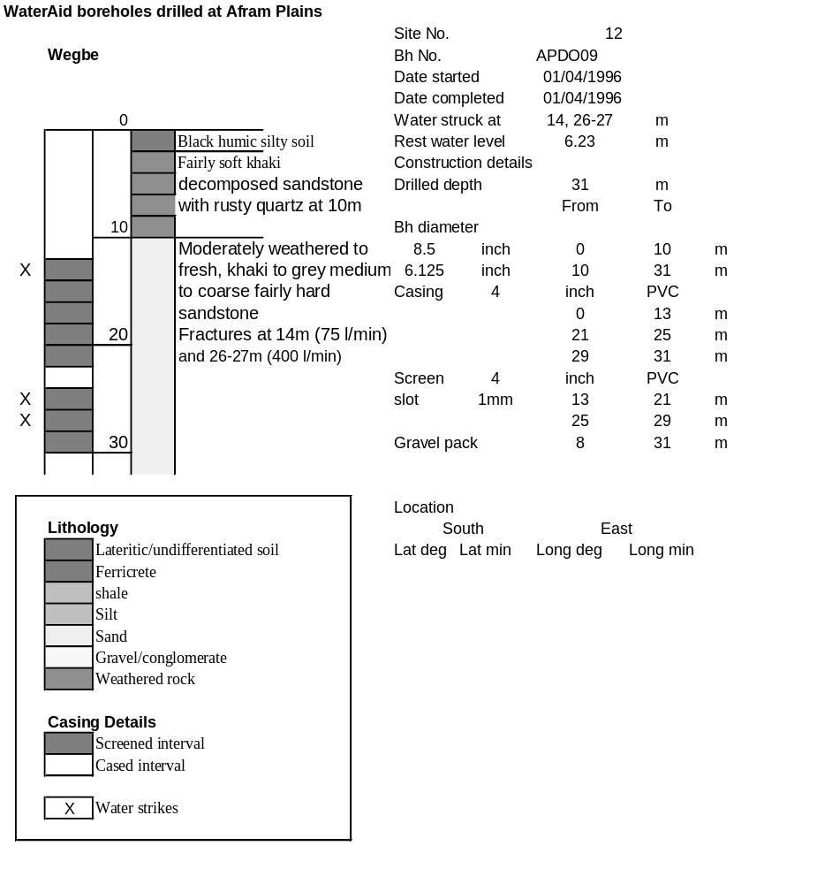

Ghana | Test pumping
Borehole No. |  | APDO9
Hole No |  | 12
Village |  | Wegbe
Date |  | 18/04/1996
Point above GL |  | 0.5 | m
Pump depth |  | 24 | m
SWL |  | 6.73 | m
Start Time |  | 13:05
Drawdown test |  |  |  |  | Recovery test
time | pwl (m) | Q l/min | dd | sc | Time | wl (m) | s' | t/t'
0.00 | 6.73 | 150.00 | 0.00 |  | 0.00 | 9.94 | 3.21
1.00 | 8.40 | 150.00 | 1.67 | 89.82 | 1.00 | 7.95 | 1.22 | 181.00
2.00 | 8.76 | 150.00 | 2.03 | 73.89 | 2.00 | 7.70 | 0.97 | 91.00
3.00 | 8.92 | 150.00 | 2.19 | 68.49 | 3.00 | 7.61 | 0.88 | 61.00
4.00 | 9.00 | 150.00 | 2.27 | 66.08 | 4.00 | 7.55 | 0.82 | 46.00
5.00 | 9.06 | 150.00 | 2.33 | 64.38 | 5.00 | 7.50 | 0.77 | 37.00
6.00 | 9.11 | 150.00 | 2.38 | 63.03 | 6.00 | 7.48 | 0.75 | 31.00
7.00 | 9.15 | 150.00 | 2.42 | 61.98 | 7.00 | 7.45 | 0.72 | 26.71
8.00 | 9.18 | 150.00 | 2.45 | 61.22 | 8.00 | 7.43 | 0.70 | 23.50
9.00 | 9.20 | 150.00 | 2.47 | 60.73 | 9.00 | 7.40 | 0.67 | 21.00
10.00 | 9.23 | 150.00 | 2.50 | 60.00 | 10.00 | 7.39 | 0.66 | 19.00
11.00 | 9.25 | 150.00 | 2.52 | 59.52 | 12.00 | 7.37 | 0.64 | 16.00
12.00 | 9.26 | 150.00 | 2.53 | 59.29 | 14.00 | 7.34 | 0.61 | 13.86
13.00 | 9.26 | 150.00 | 2.53 | 59.29 | 16.00 | 7.33 | 0.60 | 12.25
14.00 | 9.27 | 150.00 | 2.54 | 59.06 | 18.00 | 7.31 | 0.58 | 11.00
15.00 | 9.28 | 150.00 | 2.55 | 58.82 | 20.00 | 7.30 | 0.57 | 10.00
16.00 | 9.29 | 150.00 | 2.56 | 58.59 | 22.00 | 7.29 | 0.56 | 9.18
17.00 | 9.31 | 150.00 | 2.58 | 58.14 | 24.00 | 7.27 | 0.54 | 8.50
18.00 | 9.33 | 150.00 | 2.60 | 57.69 | 26.00 | 7.26 | 0.53 | 7.92
19.00 | 9.35 | 150.00 | 2.62 | 57.25 | 28.00 | 7.25 | 0.52 | 7.43
20.00 | 9.36 | 150.00 | 2.63 | 57.03 | 30.00 | 7.24 | 0.51 | 7.00
22.00 | 9.36 | 150.00 | 2.63 | 57.03 | 35.00 | 7.22 | 0.49 | 6.14
24.00 | 9.37 | 150.00 | 2.64 | 56.82 | 40.00 | 7.20 | 0.47 | 5.50
26.00 | 9.38 | 150.00 | 2.65 | 56.60 | 45.00 | 7.19 | 0.46 | 5.00
28.00 | 9.39 | 150.00 | 2.66 | 56.39 | 50.00 | 7.17 | 0.44 | 4.60
30.00 | 9.42 | 150.00 | 2.69 | 55.76 | 60.00 | 7.16 | 0.43 | 4.00
35.00 | 9.45 | 150.00 | 2.72 | 55.15 | 70.00 | 7.14 | 0.41 | 3.57
40.00 | 9.47 | 150.00 | 2.74 | 54.74 | 80.00 | 7.13 | 0.40 | 3.25
45.00 | 9.49 | 150.00 | 2.76 | 54.35 | 90.00 | 7.10 | 0.37 | 3.00
50.00 | 9.51 | 150.00 | 2.78 | 53.96 | 100.00 | 7.09 | 0.36 | 2.80
55.00 | 9.56 | 150.00 | 2.83 | 53.00 | 110.00 | 7.08 | 0.35 | 2.64
60.00 | 9.56 | 150.00 | 2.83 | 53.00 | 120.00 | 7.07 | 0.34 | 2.50
70.00 | 9.60 | 150.00 | 2.87 | 52.26
80.00 | 9.66 | 150.00 | 2.93 | 51.19
90.00 | 9.69 | 150.00 | 2.96 | 50.68
100.00 | 9.70 | 150.00 | 2.97 | 50.51
110.00 | 9.73 | 150.00 | 3.00 | 50.00
120.00 | 9.78 | 150.00 | 3.05 | 49.18
130.00 | 9.82 | 150.00 | 3.09 | 48.54
140.00 | 9.83 | 150.00 | 3.10 | 48.39
160.00 | 9.88 | 150.00 | 3.15 | 47.62
180.00 | 9.94 | 150.00 | 3.21 | 46.73
